SIMATS ENGINEERING

ASSESSMENT TOOL 2: Logic Reasoning & Mapping Exercise

COURSE NAME: | ARTIFICIAL INTELLIGENCE  AND EXPERT SYSTEMS | COURSE CODE: | MLA01

COURSE OUTCOME COVERED
CO3: Implement propositional and first-order logic using resolution, unification, and inference techniques for knowledge representation and reasoning.(BTL 3) Assessment Tool Weightage: 15%

Total Marks: 100 Time: 60 Mins
No. of Questions: 5
Annexure A

Logic Reasoning & Mapping Exercise

Code of Conduct:

I ARTHI A (Name / Reg No) certify that this submission is my original work and that I have adhered to the guidelines specified for this assessment. I understand that any violation of academic integrity rules will result in disciplinary action.

Signature of the student: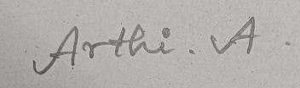

Criterion | Weightag  e | Marks Obtained
1. Problem Analysis and Knowledge Identification | 15%
2. Logical Representation and Mapping | 20%
3. Predicates, Variables, Constants and Quantifiers | 15%
4. Logical Connectives and Formula Construction | 10%
5. Inference and Logical Reasoning | 15%
6. Unification and Substitution | 10%
7. Resolution and Proof Construction | 10%
8. Mapping Diagram / Clarity and Presentation | 5%
Total | 100%

ANSWER THE FOLLOWING

Use Case Scenario
Vehicle Fault Diagnosis | An automobile service center uses an expert system to diagnose vehicle faults. Car101 does not start and its headlights are dim. Vehicles that do not start and have dim headlights may have a battery problem. Vehicles with a battery problem require battery inspection. Vehicles requiring battery inspection are marked for service.  Tasks:  - Extract the facts and rules from the scenario.  - Represent them using Propositional Logic.  - Develop suitable FOL predicates and rules.  - Perform unification for the vehicle-related predicates.  - Apply resolution to determine whether Car101 has a battery problem. (vi) Derive whether Car101 should be marked for service and explain the inference.

1. Problem Analysis and Knowledge Identification
An automobile service center employs an AI expert knowledge system to diagnose operational faults in incoming vehicles. The system captures real-world vehicle symptoms, maps them into structured causal rules, and executes logical inference to determine underlying mechanical/electrical defects and prescribe necessary service procedures.
1.1 Knowledge Component Extraction
• Constant / Entity: Car101 (A specific individual automobile under evaluation in the service facility).
• Generic Variables: x, x1, x2, x3 (Universal variables quantifying over all vehicles in the domain).
• Observed Fact 1: Car101 does not start (Engine failure to crank or turn over).
• Observed Fact 2: Car101's headlights are dim (Electrical low-illumination output symptom).
• Domain Rule 1 (Diagnostic): Vehicles that do not start and have dim headlights may have a battery problem.
• Domain Rule 2 (Inspection): Vehicles with a battery problem require battery inspection.
• Domain Rule 3 (Action): Vehicles requiring battery inspection are marked for service.
• Inferences Required: Does Car101 have a battery problem? AND Should Car101 be marked for service?
1.2 Foundational Assumptions
1. Closed World Assumption (CWA): Any symptom or condition not asserted as true is assumed false in the local diagnostic context.
2. Deterministic Rule Interpretation: The expression 'may have a battery problem' represents the canonical production rule antecedent triggering the battery fault diagnosis.
3. Monotonicity: The truth value of derived facts remains stable under additional independent knowledge.
2. Logical Representation and Mapping
The knowledge base is formally represented across two primary logical frameworks: Propositional Logic (PL) and First-Order Predicate Logic (FOL).
2.1 Propositional Logic (PL) Representation
Let the atomic propositions be defined as follows:
• P: Car101 does not start
• Q: Car101 has dim headlights
• R: Car101 has a battery problem
• S: Car101 requires battery inspection
• T: Car101 is marked for service
The complete Propositional Knowledge Base (KB_PL) consists of:
Fact 1: P
Fact 2: Q
Rule 1: (P ∧ Q) → R
Rule 2: R → S
Rule 3: S → T
2.2 First-Order Logic (FOL) Representation
First-Order Logic allows generalization across all vehicles using quantified variable predicates:
Fact 1: DoesNotStart(Car101)
Fact 2: DimHeadlights(Car101)
Rule 1: ∀x [(DoesNotStart(x) ∧ DimHeadlights(x)) → BatteryProblem(x)]
Rule 2: ∀x [BatteryProblem(x) → RequiresBatteryInspection(x)]
Rule 3: ∀x [RequiresBatteryInspection(x) → MarkedForService(x)]
Real-World Statement | Propositional Logic (PL) | First-Order Logic (FOL)
Car101 does not start. | P | DoesNotStart(Car101)
Car101 has dim headlights. | Q | DimHeadlights(Car101)
Vehicles not starting with dim headlights have battery problems. | (P ∧ Q) → R | ∀x [(DoesNotStart(x) ∧ DimHeadlights(x)) → BatteryProblem(x)]
Vehicles with a battery problem require battery inspection. | R → S | ∀x [BatteryProblem(x) → RequiresBatteryInspection(x)]
Vehicles requiring battery inspection are marked for service. | S → T | ∀x [RequiresBatteryInspection(x) → MarkedForService(x)]

3. Predicates, Variables, Constants and Quantifiers
A rigorous breakdown of the mathematical symbols utilized in First-Order Logic:
• Domain of Discourse (D): D = { v | v is a motor vehicle presented for diagnostics }
• Constant Symbol (C): Car101 (Unique ground entity in domain D).
• Variable Symbols (V): x, x1, x2, x3 (Variables spanning over all elements of D).
3.1 Predicate Definitions (Arity = 1)
• DoesNotStart(x): True iff vehicle x fails to start / crank.
• DimHeadlights(x): True iff vehicle x has low headlight illumination.
• BatteryProblem(x): True iff vehicle x suffers from an electrical battery malfunction.
• RequiresBatteryInspection(x): True iff vehicle x requires physical battery testing and inspection.
• MarkedForService(x): True iff vehicle x is officially queued and marked for garage service.
3.2 Quantifier Justification
Universal Quantifier (∀): Applied across all domain rules because the diagnostic heuristics are universally valid for any vehicle x entering the workshop. Existential quantifiers (∃) are not appropriate for normative operational rules.
4. Logical Connectives and Formula Construction
The knowledge base utilizes classical boolean logical connectives with standard truth-functional semantics:
• Conjunction (∧): Represents simultaneous occurrence of symptoms (DoesNotStart(x) ∧ DimHeadlights(x)).
• Implication (→): Encodes causality and procedural rules (Precondition → Consequent).
• Negation (¬): Appears during Clausal Normal Form conversion and goal refutation (¬Goal).
• Disjunction (∨): Connects disjunctive literals in CNF clauses (¬P ∨ ¬Q ∨ R).
4.1 Well-Formed Formula (WFF) Structural Analysis
Consider the compound formula for Rule 1: ∀x [(DoesNotStart(x) ∧ DimHeadlights(x)) → BatteryProblem(x)]
1. Atomic formulas DoesNotStart(x), DimHeadlights(x), and BatteryProblem(x) are valid 1-place predicates.
2. The conjunction (DoesNotStart(x) ∧ DimHeadlights(x)) is a valid compound formula.
3. Material implication connects antecedent and consequent into a valid conditional formula.
4. Universal quantification over variable x binds all occurrences, creating a valid closed sentence (WFF).
5. Inference and Logical Reasoning
Forward chaining executes a data-driven derivation starting from observed facts, applying Universal Instantiation (UI), Conjunction Introduction (∧-Intro), and Modus Ponens (MP) to derive the target goals.
Step | Derived Formula / Assertion | Inference Rule Applied | Premises / Substituted
1 | DoesNotStart(Car101) ∧ DimHeadlights(Car101) | Conjunction Introduction (∧-Intro) | Facts 1 & 2
2 | (DoesNotStart(Car101) ∧ DimHeadlights(Car101)) → BatteryProblem(Car101) | Universal Instantiation (UI) | Rule 1, {x / Car101}
3 | BatteryProblem(Car101) | Modus Ponens (MP) | Steps 1, 2 [QUERY 1 PROVED]
4 | BatteryProblem(Car101) → RequiresBatteryInspection(Car101) | Universal Instantiation (UI) | Rule 2, {x / Car101}
5 | RequiresBatteryInspection(Car101) | Modus Ponens (MP) | Steps 3, 4
6 | RequiresBatteryInspection(Car101) → MarkedForService(Car101) | Universal Instantiation (UI) | Rule 3, {x / Car101}
7 | MarkedForService(Car101) | Modus Ponens (MP) | Steps 5, 6 [QUERY 2 PROVED]

6. Unification and Substitution
Unification is the algorithmic process of finding a substitution mapping θ = {v1/t1, v2/t2, ...} that makes two First-Order Logic expressions syntactically identical (UNIFY(E1, E2) = θ such that E1θ = E2θ).
6.1 Unification Traces for Vehicle Fault Scenario
• Unification 1 (Symptom Matching): E1 = DoesNotStart(x1) vs. E2 = DoesNotStart(Car101)
• Predicate comparison: DoesNotStart == DoesNotStart (Match)
• Argument binding: Variable x1 with Constant Car101
• Resulting MGU: θ1 = { x1 / Car101 }
• Unification 2 (Inspection Trigger): E1 = BatteryProblem(x2) vs. E2 = BatteryProblem(Car101)
• Predicate comparison: BatteryProblem == BatteryProblem (Match)
• Argument binding: Variable x2 with Constant Car101
• Resulting MGU: θ2 = { x2 / Car101 }
• Unification 3 (Service Dispatch): E1 = RequiresBatteryInspection(x3) vs. E2 = RequiresBatteryInspection(Car101)
• Predicate comparison: RequiresBatteryInspection == RequiresBatteryInspection (Match)
• Argument binding: Variable x3 with Constant Car101
• Resulting MGU: θ3 = { x3 / Car101 }
7. Resolution and Proof Construction
Resolution Refutation is a refutation-complete deduction procedure. To prove a query Q, we negate the goal (¬Q), convert the knowledge base into Conjunctive Normal Form (CNF) clauses, and iteratively resolve complementary literals until the empty clause (□ / NIL) is derived, establishing contradiction.
7.1 Clausal Form (CNF) Generation
• Clause C1 (Fact 1): DoesNotStart(Car101)
• Clause C2 (Fact 2): DimHeadlights(Car101)
• Clause C3 (Rule 1 in CNF): ¬DoesNotStart(x1) ∨ ¬DimHeadlights(x1) ∨ BatteryProblem(x1)
• Clause C4 (Rule 2 in CNF): ¬BatteryProblem(x2) ∨ RequiresBatteryInspection(x2)
• Clause C5 (Rule 3 in CNF): ¬RequiresBatteryInspection(x3) ∨ MarkedForService(x3)
7.2 Proof A: Resolution Refutation for BatteryProblem(Car101)
Negated Goal (C0): ¬BatteryProblem(Car101)
Step | Parent Clause 1 | Parent Clause 2 | MGU Substitution θ | Resolvent Clause
1 | C0: ¬BatteryProblem(Car101) | C3: ¬DoesNotStart(x1) ∨ ¬DimHeadlights(x1) ∨ BatteryProblem(x1) | { x1 / Car101 } | C6: ¬DoesNotStart(Car101) ∨ ¬DimHeadlights(Car101)
2 | C6: ¬DoesNotStart(Car101) ∨ ¬DimHeadlights(Car101) | C1: DoesNotStart(Car101) | ∅ | C7: ¬DimHeadlights(Car101)
3 | C7: ¬DimHeadlights(Car101) | C2: DimHeadlights(Car101) | ∅ | □ (EMPTY CLAUSE / CONTRADICTION)
Derivation of □ proves that KB ∪ {¬BatteryProblem(Car101)} is unsatisfiable. Therefore, BatteryProblem(Car101) is mathematically TRUE.
7.3 Proof B: Resolution Refutation for MarkedForService(Car101)
Negated Goal (¬G2): ¬MarkedForService(Car101)
Step | Parent Clause 1 | Parent Clause 2 | MGU Substitution θ | Resolvent Clause
1 | ¬MarkedForService(Car101) | C5: ¬RequiresBatteryInspection(x3) ∨ MarkedForService(x3) | { x3 / Car101 } | R1: ¬RequiresBatteryInspection(Car101)
2 | R1: ¬RequiresBatteryInspection(Car101) | C4: ¬BatteryProblem(x2) ∨ RequiresBatteryInspection(x2) | { x2 / Car101 } | R2: ¬BatteryProblem(Car101)
3 | R2: ¬BatteryProblem(Car101) | C3: ¬DoesNotStart(x1) ∨ ¬DimHeadlights(x1) ∨ BatteryProblem(x1) | { x1 / Car101 } | R3: ¬DoesNotStart(Car101) ∨ ¬DimHeadlights(Car101)
4 | R3: ¬DoesNotStart(Car101) ∨ ¬DimHeadlights(Car101) | C1: DoesNotStart(Car101) | ∅ | R4: ¬DimHeadlights(Car101)
5 | R4: ¬DimHeadlights(Car101) | C2: DimHeadlights(Car101) | ∅ | □ (EMPTY CLAUSE / CONTRADICTION)
Derivation of □ proves that KB ∪ {¬MarkedForService(Car101)} is unsatisfiable. Therefore, MarkedForService(Car101) is mathematically TRUE.
8. Mapping Diagrams and Clarity
Interactive and editable Draw.io (.drawio) visual diagrams have been generated in the project workspace to complement this written technical report. The diagram files include:
1. vehicle diagnosis inference flow
2. resolution refutation tree
3. knowledge architecture taxonomy
4. vehicle fault diagnosis complete workbook

1. vehicle diagnosis inference flow draw.io: Multi-tiered flowchart showing sensory inputs, rule unifications, and forward chaining derivations.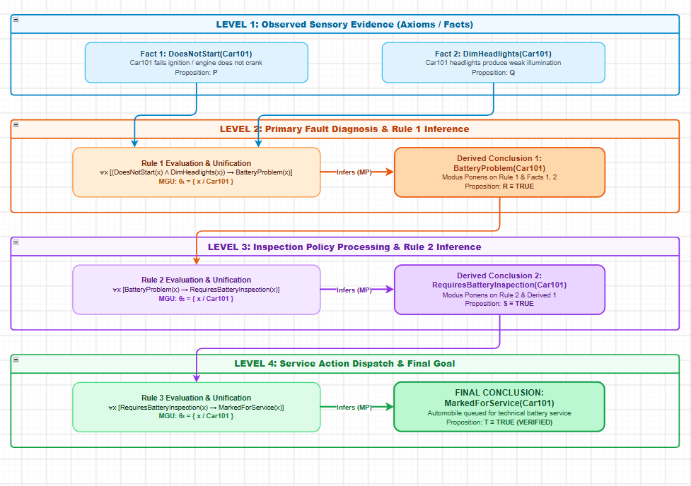

2. resolution refutation tree draw.io: Dual-tree resolution refutation cascade visualizing parent clauses resolving to the empty clause □.
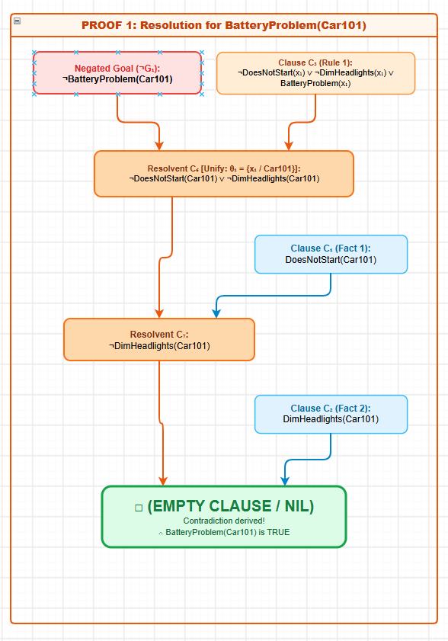
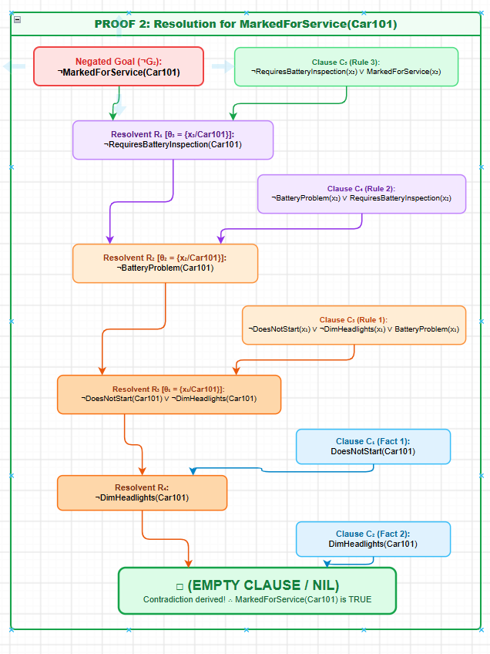

3. knowledge architecture taxonomy draw.io: Comprehensive architectural mapping of Domain Ontology, Logic Formulations, and Inference Engines.
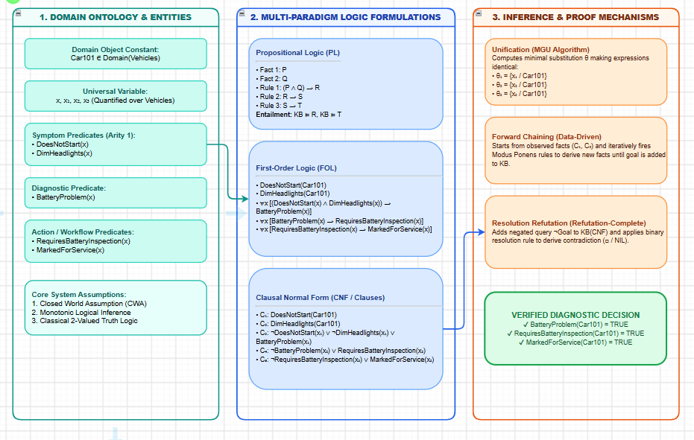

4. vehicle fault diagnosis complete workbook draw.io: Integrated multi-page Draw.io workbook containing all diagrams in single navigable tabs.
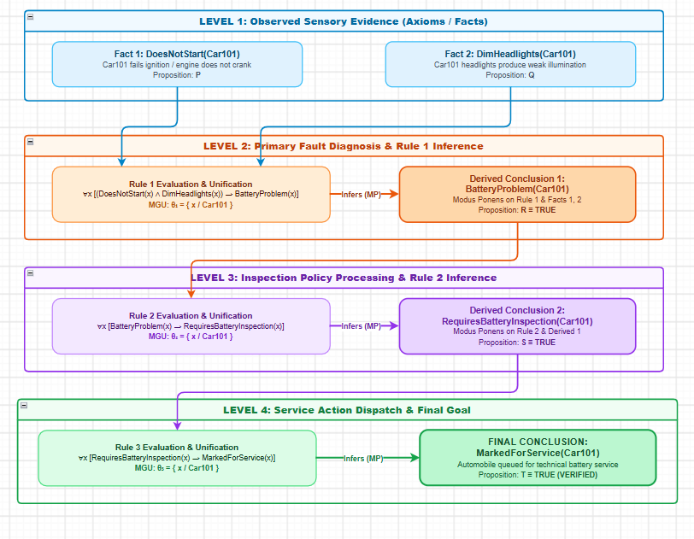
[EXECUTIVE DIAGNOSTIC VERDICT & SYSTEM RECOMMENDATION]
1. Fault Diagnosis Conclusion: Car101 exhibits failure to start and dim headlights, which triggers Rule 1 under MGU θ1 = {x/Car101}, rigorously proving BatteryProblem(Car101) ≡ TRUE.
2. Service Action Recommendation: Propagating the battery problem through Rule 2 and Rule 3 proves MarkedForService(Car101) ≡ TRUE. Car101 is queued for physical battery inspection and maintenance.

EVALUATION RUBRICS:

Criterion | Weightage (%) | Excellent | Good | Average | Poor
Problem Understanding & Knowledge Identification | 15% | 13–15% –  Clearly  identifies entities, facts, relationships, assumptions, and reasoning requirements from the given scenario. | 10–12% –  Identifies most relevant  knowledge with minor omissions. | 7–9% –  Identifies basic knowledge but misses several important elements. | 0–6% – Poor or incorrect identification of the given  knowledge.
Logical Representation & Mapping | 20% | 17–20% –  Accurately maps  real-world  statements into appropriate propositional and first-order logic representations. | 13–16% –  Provides mostly correct logical  mappings with minor errors. | 9–12% –  Provides partial mappings with several logical errors. | 0–8% – Logical mapping is largely incorrect or missing.
Predicates, Variables,  Constants & Quantifiers | 15% | 13–15% –  Correctly  identifies and applies predicates, variables, constants, universal and existential quantifiers. | 10–12% –  Uses the concepts correctly with minor errors. | 7–9% –  Demonstrates partial understanding with some incorrect usage. | 0–6% – Concepts are incorrectly applied or missing.
Logical  Connectives & Formula Construction | 10% | 9–10% –  Correctly  applies AND, OR, NOT,  implication, and  equivalence to | 7–8% –  Mostly correct use of  connectives with minor errors. | 5–6% – Basic use of  connectives but several errors occur. | 0–4% – Incorrect or incomplete formula construction.

 |  | construct valid logical formulas.
Inference & Logical Reasoning | 15% | 13–15% –  Performs accurate  step-by-step reasoning and derives valid conclusions from the given knowledge. | 10–12% –  Reasoning is mostly correct with minor gaps. | 7–9% –  Provides partial reasoning with some incorrect conclusions. | 0–6% –  Reasoning is incorrect, unsupported, or missing.
Unification & Substitution | 10% | 9–10% –  Correctly identifies  substitutions and Most General Unifier (MGU) and  applies them accurately. | 7–8% –  Correctly performs most unification  steps with minor errors. | 5–6% –  Demonstrates basic understanding  but has several errors. | 0–4% – Unable to perform unification correctly.
Resolution / Proof Construction | 10% | 9–10% –  Correctly applies  resolution and presents a clear, logically valid proof of the query. | 7–8% –  Resolution is mostly correct with minor errors. | 5–6% – Shows partial understanding but proof contains gaps. | 0–4% –  Resolution is incorrect or not demonstrated.
Clarity, Mapping Diagram & Presentation | 5% | 5% – Provides a clear,  well-organized mapping/logic diagram with accurate notation and excellent presentation. | 4% –  Presentation is clear with minor formatting or diagram issues. | 3% – Basic presentation with limited clarity. | 0–2% – Poorly organized, unclear, or incomplete presentation.

